**TASK 1**

**Starting Topology**

**PC Configuration**

**Router 1 Configuration for IP**

**Router 1 Initial Routing for IP**

**Router 2 Configuration for IP**

**Router 2 Initial Routing for IP**

**Dynamic NAT Implementation on Router 1**

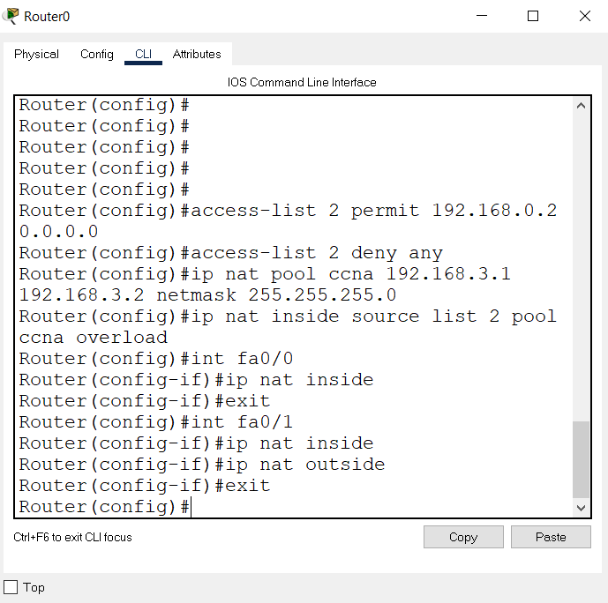

**Router 1 is with PAT and Router 2 is Statically Configured**

**Router 1 Statistics**

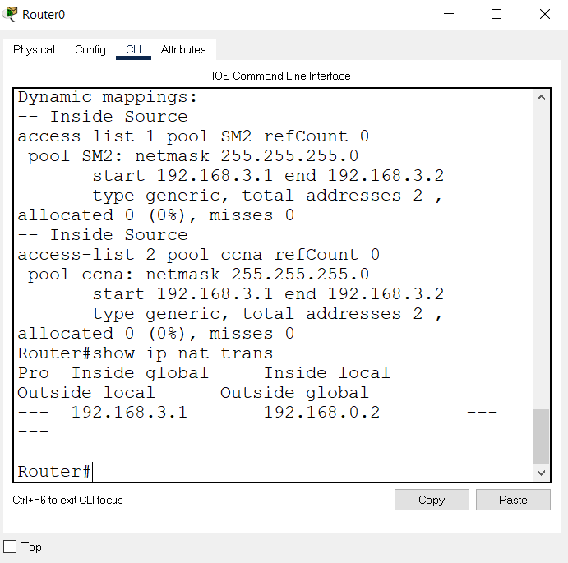

**Successful Message Passing**

